## Exp : **Design an automatic night lighting system such the system is only activated when the master control switch is pressed. a) Below 50% value of full brightness led blinks with a freq. of 500 msec. b) Above 50% value of full brightness led blinks with a freq. of 100 msec.**

Circuit Diagram: 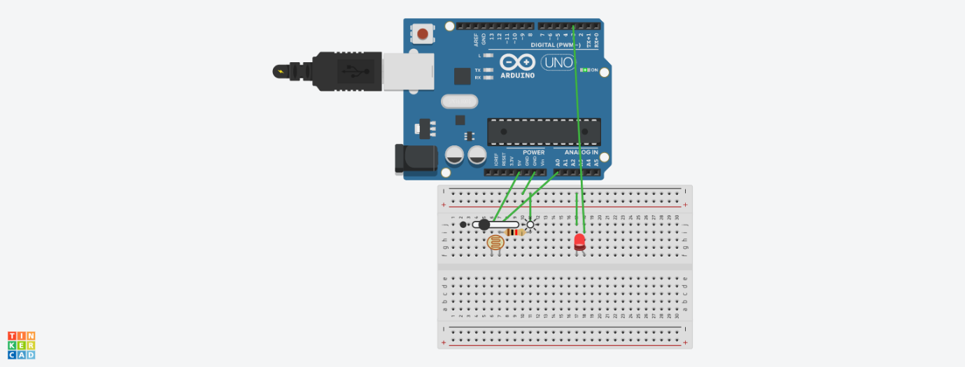

## **Concept Used** : blink LED 60 times a minute and stops blinking and turns blue during night.

Learning & Observations:

The LED light glow sat different period of time at different brightness.

Problems & Troubleshooting:

1. Problem in fixing wire from bread board to arduino.
2. Problem in doing arduino programming.
3. Problems in understanding the logic.

Precautions:

1. Correct connection of negative and positive terminal of led.
2. Don’t put arduino near water.
3. Check the USB port of computer is working.
4. Check the arduino software and select the correct port (in which arduino is connected).

Learning Outcome:

1. LED light glow of different speed at different brightness of surroundings.
2. Arduino function as a controller in led’s.
3. Bread board is used to organize the circuit.

**CODING:**

const int ldrPin=A0;

void setup() {

Serial.begin(9600);

pinMode(ldrPin,INPUT);

pinMode(3,OUTPUT);

}

void loop() {

int ldrStatus=analogRead(ldrPin);

if(ldrStatus<=150) {

digitalWrite(3,HIGH);

delay (500);

digitalWrite(3,LOW);

delay(500);

}

else if(ldrStatus>=150)

{

digitalWrite(3,HIGH);

delay(100);

digitalWrite(3,LOW);

delay(100);

}

}